BLOCK DIAGRAM
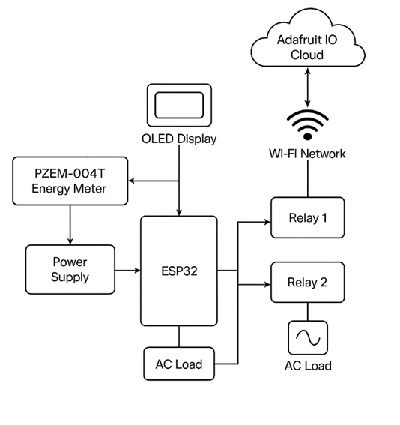

The block diagram illustrates the working principle of the ESP32-based power monitoring and control system:
- Power Measurement using PZEM-004T
  - The PZEM-004T module measures real-time AC voltage, current, power, and energy consumption of the connected load.
  - This data is transmitted to the ESP32 via UART communication.
- ESP32 Microcontroller
  - Acts as the main control unit.
  - Receives power consumption data from PZEM-004T.
  - Controls two relays to switch loads ON/OFF.
  - Connects to Wi-Fi and communicates with Adafruit IO Cloud for remote monitoring.
- Relay Control for Load Management
  - Two relays are used to turn ON/OFF connected AC loads based on user input or automation logic.
  - This enables load segregation and power factor optimization, reducing penalties for excessive reactive power.
- Wi-Fi and Cloud Integration
  - The ESP32 connects to the internet via Wi-Fi.
  - It sends real-time power data to Adafruit IO Cloud, allowing users to monitor power usage remotely.
  - Users can send control signals from a web dashboard or mobile app to toggle relays.

- Power Supply Unit
  - Ensures proper voltage levels to power the ESP32, PZEM-004T, and relay modules.
This system provides real-time power monitoring, remote control of loads, and cost-effective power factor management, making it suitable for industrial and commercial applications.

